Surface Area

Definition
# Source: AI Source: Provided by: [Data Path: Persons Table -> ID Column: 1, Name_En Column: Motasem Essam] -> From: [ChatGPT] on [7/17/2026]
Surface Area is the total area covering the outer surface of a three-dimensional (3D) object. It is the sum of the areas of all the object's exposed faces or curved surfaces.
Surface area measures how much material is needed to cover the outside of a solid object.

Characteristics
# Source: AI Source: Provided by: [Data Path: Persons Table -> ID Column: 1, Name_En Column: Motasem Essam] -> From: [ChatGPT] on [7/17/2026]
Surface area:
- Measures the entire outer surface of a 3D object.
- Is expressed in square units.
- Includes all flat and curved surfaces.
- Depends on the shape and dimensions of the object.
- Is different from volume, which measures the space inside an object.

Illustration
# Source: AI Source: Provided by: [Data Path: Persons Table -> ID Column: 1, Name_En Column: Motasem Essam] -> From: [ChatGPT] on [7/17/2026]
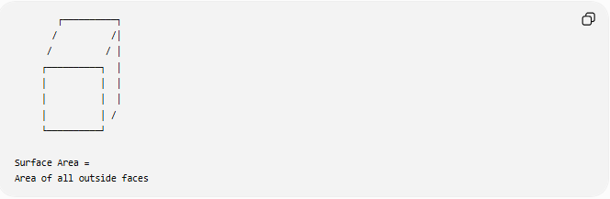
┌──────────┐
/ /│
/ / │
┌──────────┐ │
│ │ │
│ │ │
│ │ /
└──────────┘

Surface Area =
Area of all outside faces

Measurement Units
# Source: AI Source: Provided by: [Data Path: Persons Table -> ID Column: 1, Name_En Column: Motasem Essam] -> From: [ChatGPT] on [7/17/2026]
Surface area is measured in square units, such as:
Metric Units
- Square millimeter (mm²)
- Square centimeter (cm²)
- Square meter (m²)
- Square kilometer (km²)
Imperial Units
- Square inch (in²)
- Square foot (ft²)
- Square yard (yd²)
- Square mile (mi²)

Common Formulas
# Source: AI Source: Provided by: [Data Path: Persons Table -> ID Column: 1, Name_En Column: Motasem Essam] -> From: [ChatGPT] on [7/17/2026]
Cube
$$SA=6s^{2}$$
where:
- $s$= side length

Rectangular Prism
$$SA=2\left(lw+lh+wh\right)$$
where:
- $l$= length
- $w$= width
- $h$= height

Cylinder
$$SA=2πr\left(r+h\right)$$
where:
- $r$= radius
- $h$= height

Sphere
$$SA=4πr^{2}$$
where:
- $r$= radius

Cone
$$SA=πr\left(r+l\right)$$
where:
- $r$= radius
- $l$= slant height

Measuring Instruments
# Source: AI Source: Provided by: [Data Path: Persons Table -> ID Column: 1, Name_En Column: Motasem Essam] -> From: [ChatGPT] on [7/17/2026]
Dimensions used to calculate surface area may be measured using:
- Ruler
- Measuring Tape
- Vernier Caliper
- Micrometer
- Laser Distance Meter
- Coordinate Measuring Machine (CMM)

Examples
# Source: AI Source: Provided by: [Data Path: Persons Table -> ID Column: 1, Name_En Column: Motasem Essam] -> From: [ChatGPT] on [7/17/2026]
Surface area is commonly calculated for:
- Boxes
- Cylinders
- Pipes
- Water tanks
- Buildings
- Packaging
- Storage containers
- Mechanical components

Applications
# Source: AI Source: Provided by: [Data Path: Persons Table -> ID Column: 1, Name_En Column: Motasem Essam] -> From: [ChatGPT] on [7/17/2026]
Surface area is used in:
- Geometry
- Engineering
- Architecture
- Construction
- Manufacturing
- Packaging
- Painting
- Heat Transfer
- Material Estimation
- CAD (Computer-Aided Design)

Advantages
# Source: AI Source: Provided by: [Data Path: Persons Table -> ID Column: 1, Name_En Column: Motasem Essam] -> From: [ChatGPT] on [7/17/2026]
Calculating surface area helps to:
- Estimate coating or paint requirements.
- Determine wrapping or packaging material.
- Analyze heat transfer.
- Design manufactured parts.
- Estimate construction materials.

Limitations
# Source: AI Source: Provided by: [Data Path: Persons Table -> ID Column: 1, Name_En Column: Motasem Essam] -> From: [ChatGPT] on [7/17/2026]
Surface area:
- Does not measure the space inside an object.
- Requires different formulas for different shapes.
- May require approximation for irregular objects.

Difference Between Surface Area and Volume
# Source: AI Source: Provided by: [Data Path: Persons Table -> ID Column: 1, Name_En Column: Motasem Essam] -> From: [ChatGPT] on [7/17/2026]
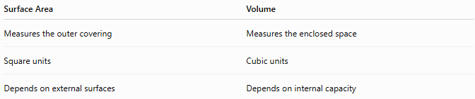
Surface Area | Volume
Measures the outer covering | Measures the enclosed space
Square units | Cubic units
Depends on external surfaces | Depends on internal capacity

Key Points
# Source: AI Source: Provided by: [Data Path: Persons Table -> ID Column: 1, Name_En Column: Motasem Essam] -> From: [ChatGPT] on [7/17/2026]
- Surface Area is the total area of all outer surfaces of a three-dimensional object.
- It is measured in square units.
- Different solids have different surface area formulas.
- Surface area is widely used in engineering, architecture, construction, manufacturing, packaging, and heat-transfer analysis.

Conclusion
# Source: AI Source: Provided by: [Data Path: Persons Table -> ID Column: 1, Name_En Column: Motasem Essam] -> From: [ChatGPT] on [7/17/2026]
Surface Area is the measurement of the total outer covering of a three-dimensional object and represents the amount of surface exposed to the surrounding environment. Unlike volume, which measures enclosed space, surface area quantifies the external region and is expressed in square units. It is a fundamental concept in geometry, engineering, architecture, construction, manufacturing, packaging, CAD, material estimation, and thermal analysis, where accurate surface calculations are essential for design, production, coating, insulation, and scientific applications.

